MMS Copy
Option 1
Come in now to purchase your new glasses with us, and we will offer you 3 months FREE contact lenses*.

Whether you’re on holidays, playing sport or having an evening out there are often times when you just don’t feel like wearing your glasses. Contact lenses give you that option so ask your optometrist today about options available to you.
Valid until 31st October 2020. To make your appointment today visit (insert practice link)
To opt out click here
Option 2
There are often times when your glasses just don’t offer the freedom and flexibility your life requires. Contact lenses could be the perfect alternative to glasses.

Purchase glasses or sunglasses from us before 31st October 2020 and you can try 3 months FREE contact lenses*.
Discover the freedom contact lenses can offer, make your appointment today. Visit (insert practice link).
Valid until 31st October 2020
To opt out click here

SMS Copy
1
There are often times when you just don’t feel like wearing your glasses. Come in now to purchase your new glasses with us, and we will offer you 3 months FREE contact lenses*. Make your appointment today by visiting (insert practice link)

2
Purchase glasses or sunglasses from us before 31st October 2020 and you can try 3 months FREE contact lenses*. So make an appointment today by visiting (insert link)

*Refer to your eyecare practitioner to determine if this product is suitable for you. Fitting and prescription may be required, and fees may apply. Visit store for Terms and Conditions.
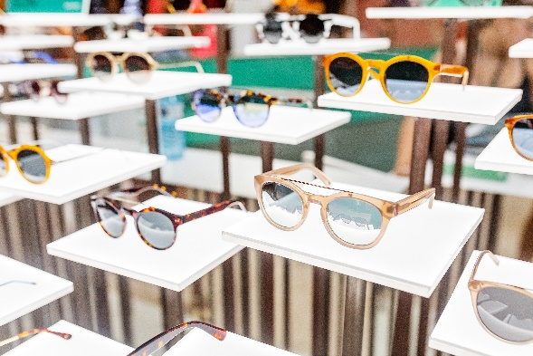*Image options available via IOG hub

